1. Write a script to **find the last but one element** of a list. [Input: [1,2,3,4] Output: 3]

1. Write a script to **find the kth element of list**, where k is the index.  [Input: [1,2,3,4] k=2 Output: 3]

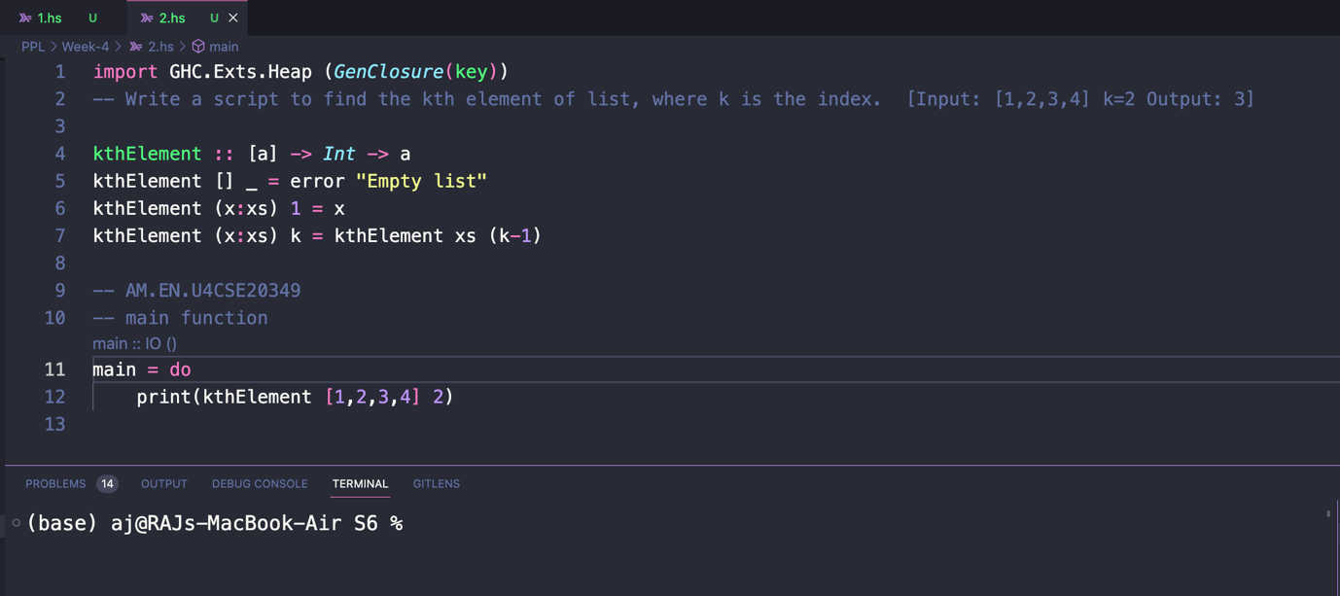

1. Write a script to find out whether a list is a **palindrome**. [Input1: [1,2,1] Output: True, Input2="mom" Output2:True]

1. Write a script to **remove duplicates** from a given list. [Input : [1,1,2,3] Output: [1,2,3]]

1. Define a function duplicate which will **duplicate each element of the list**and produce a new list. Example [1,23] - will give output [1,1,2,2,3,3].

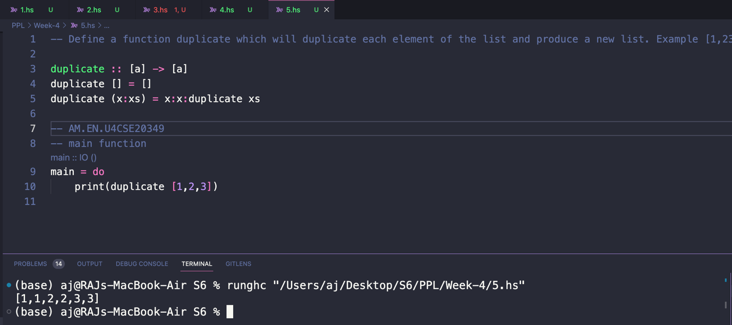

1. Define a function to **replicate the elements of a list n times**. Let [1,2]be a list and let n be 3, then the resultant list will be [1,1,1,2,2,2].

1. Write a function to **remove every nth element**from the list. Let **[1,2,3,4,5,6,7,8,9,10]** be the list and value of**n be 3**, then the resultant list will be [1,2,4,5,7,8,10]( after every nth element of the input list is [1,2,3,4,5,6,7,8,9,10] removed).

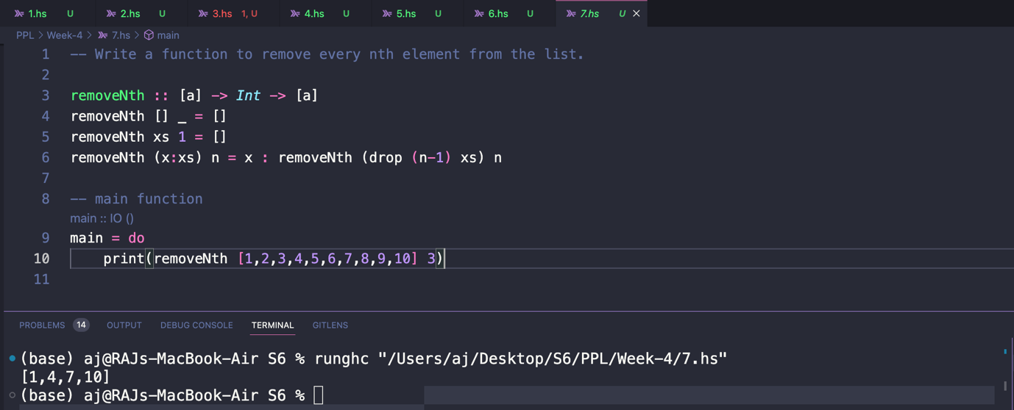

1. **Split a list** by defining a function which takes an input **list**and an **integer n** and divides the list into two the**first n elements as the first list**and **the rest as the second list** and form a list of lists.  Let [1..10] be a list and value of n be 4 then the new list formed is [1,2,3,4],[5,6,7,8,9,10](https://amritauniv.sharepoint.com/sites/PPL_2022/SitePages/1,2,3,4%5D,%5B5,6,7,8,9,10.aspx). Another example I/P splits "amr" 4 & O/P- ["amr",""]

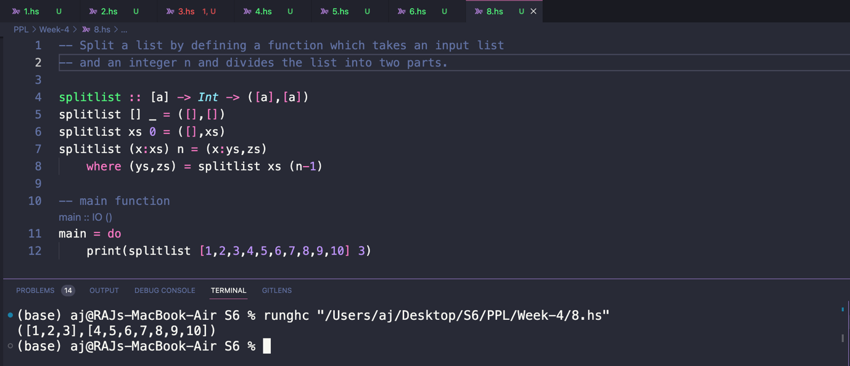

1. Define a function that will **slice a list** based on the input indices i and k. Consider a list**[1..10]** and let**i = 2**and **k = 4**respectively then the resultant list will be **[3,4,5].**

1. Define a function to **remove the kth indexed element** from a list. Consider a list [1..10], and value of **n** be **2**, then resultant list will be [1,2,4,5,6,7,8,9,10].

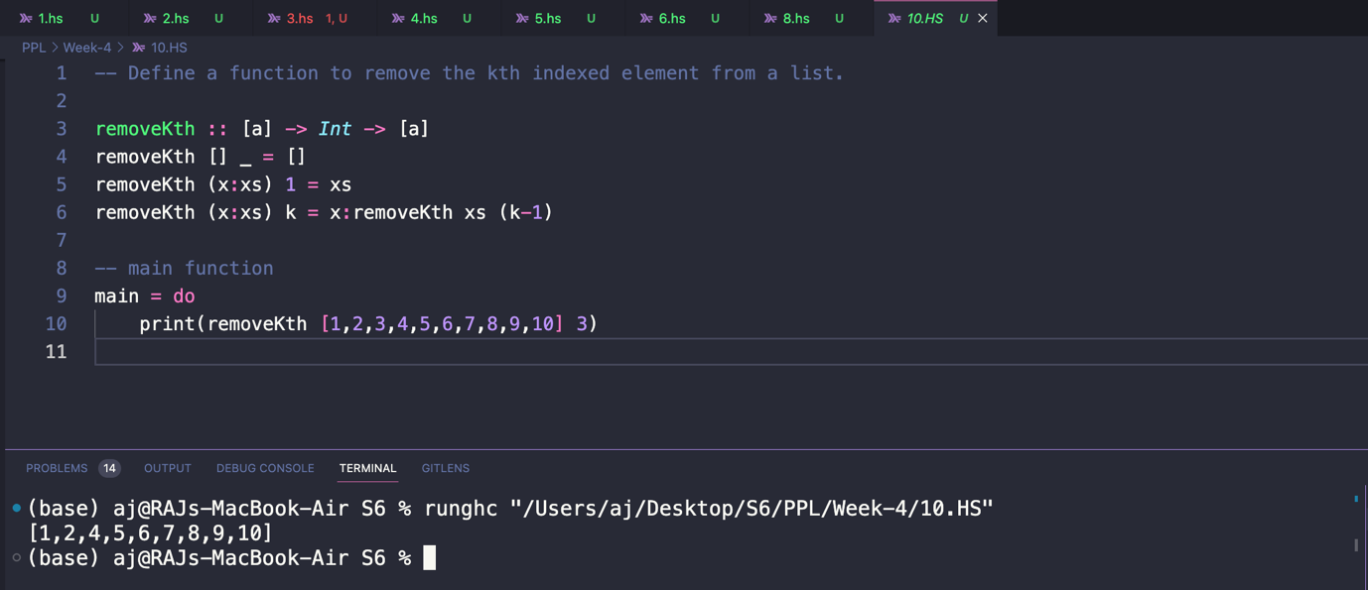

1. Define a function that will **insert an element** n **at a particular index** i of a list xs. Let xs=[1..10], i=2, n=11, then the output will be [1,2,11,3,4,5,6,7,8,9,10].

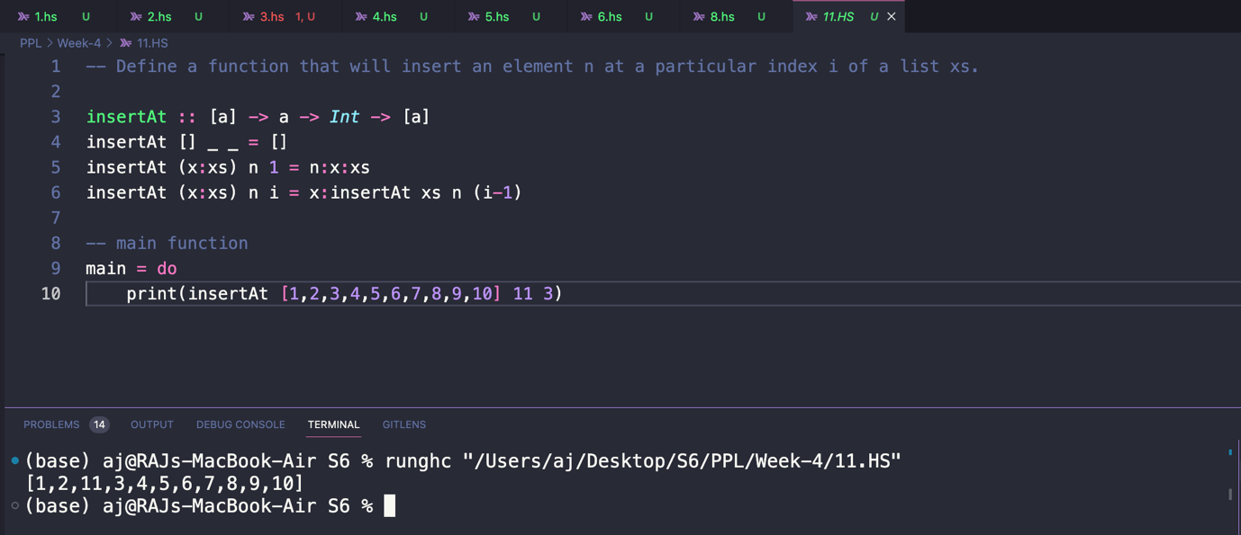

1. Define a function that takes an integer number **n**and returns the list of the **first n prime numbers**.

1. Define a predicate to verifies whether a list is sorted in **ascending order**.

1. Define a function **myCons**that behaves as **:**but is defined in terms of **++.**

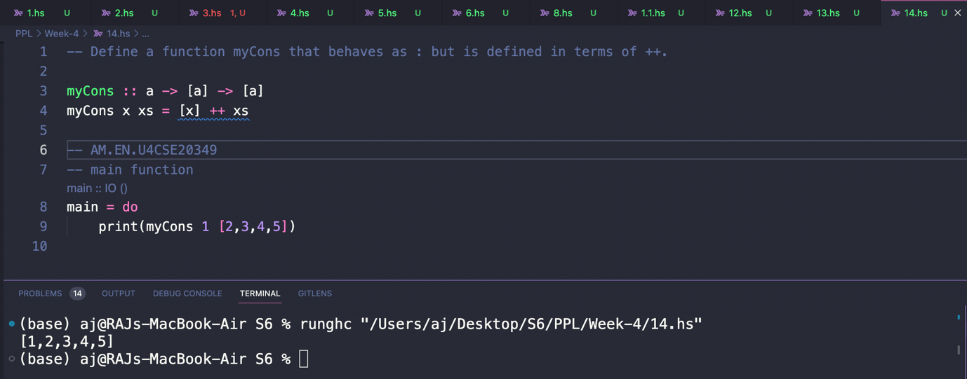

1. Define a function that takes an integer **number n** and a **value v** and creates a list containing**n occurrences of v.**

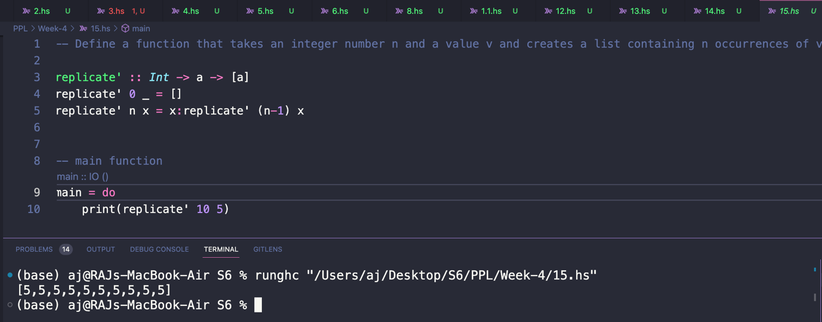

1. To find all the digits in a string  where the prelude function

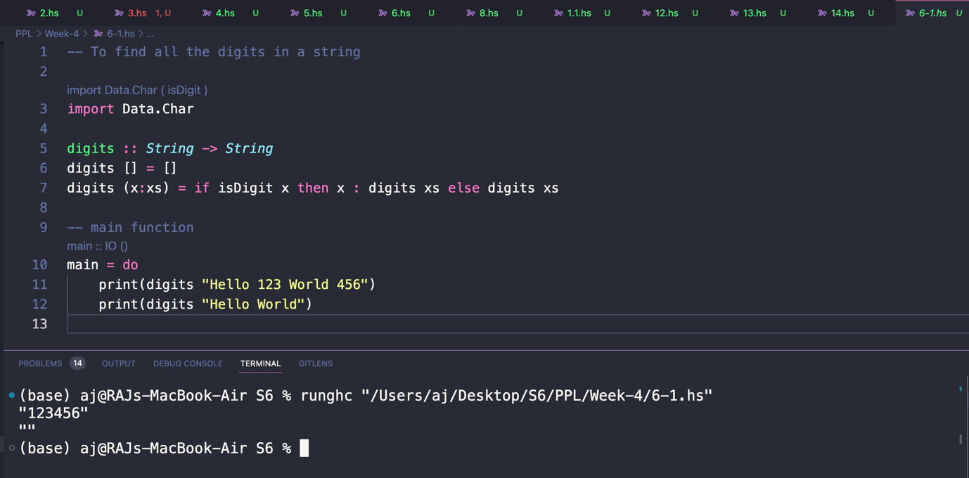

1. Give a definition of a function which **doubles all** the elements of a list of integers

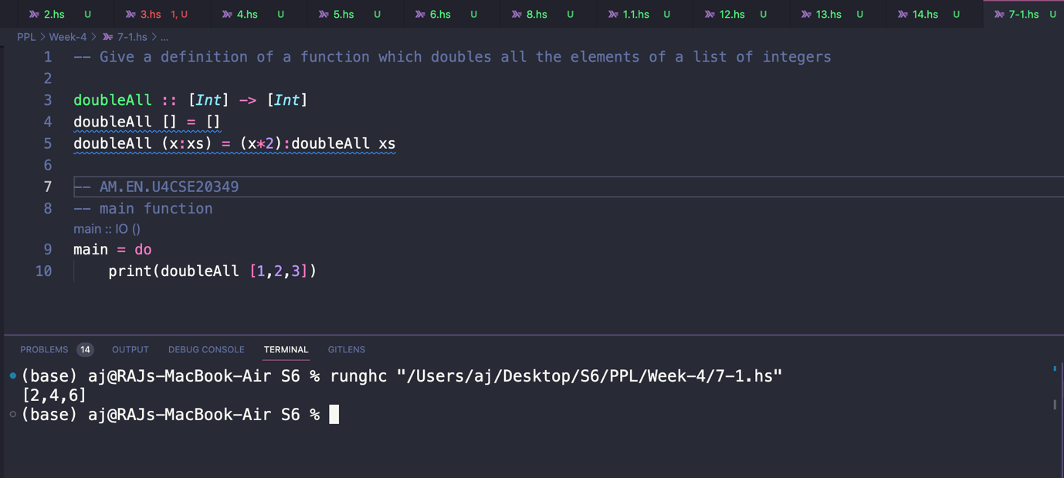

1. Give a definition of a function which **converts**all**small letters** in a String**into capitals**, leaving the other characters unchanged.

1. How would you modify above function to give which behaves in the same way except that all non-letters are removed from the list? You should check the Char .hs library to see whether it contains any functions useful in solving this problem.

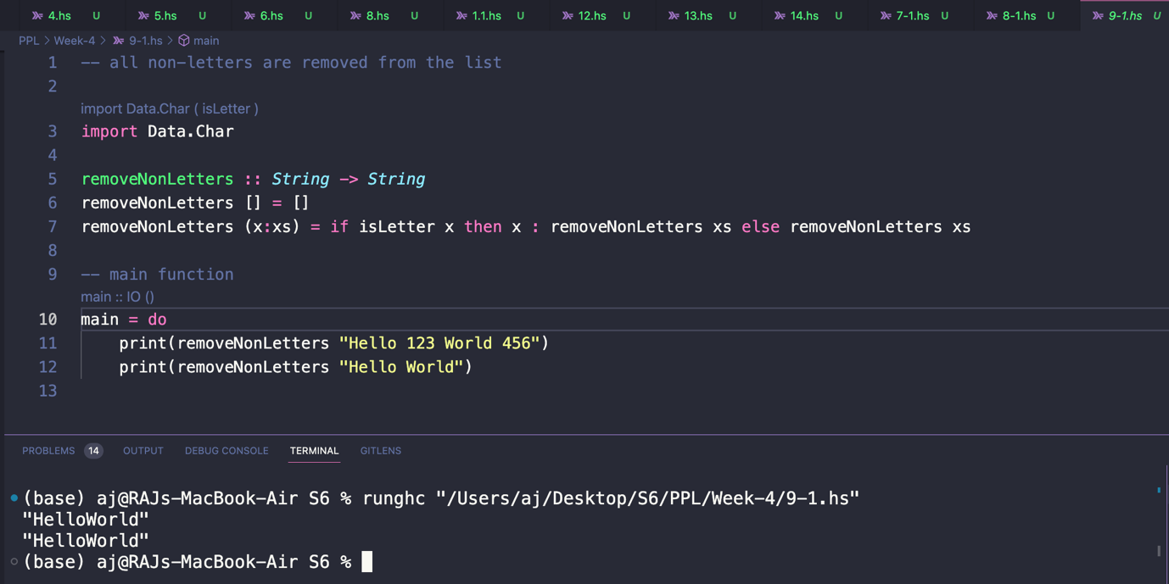

1. Define the function which **returns**the **list of divisors**of a**positive integer** (and the empty list for other inputs).

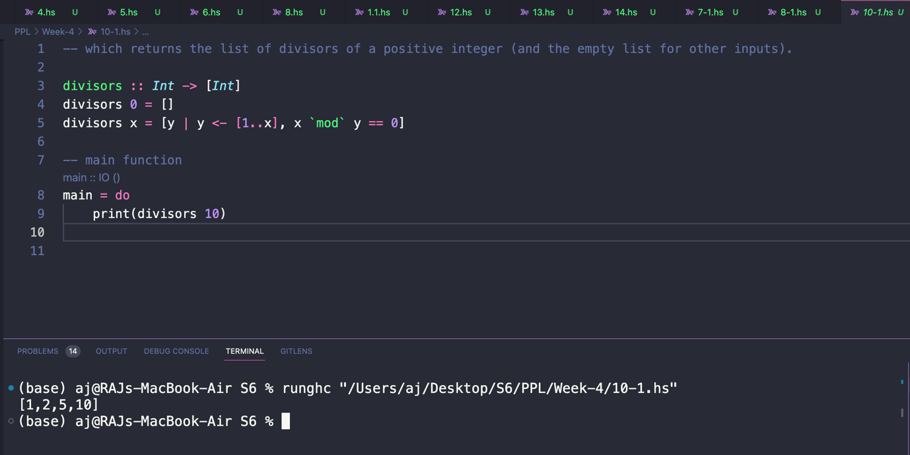

1. Define the function which picks out all occurrences of an integer n in a list. For instance,

1. Using matches or otherwise, define a function which is **True**if the **Int**is **an element** of the list, and **False otherwise**.

1. Given a list of lists, sum the lengths of inner lists - sumLength [ [1,2][2,3][5,7,8,9] ] must  return 8

